# **Assignment 3- Chapter 8 – Control Structures**

**Objectives**: The objectives of this assignment are:

1. Write a complete assembly program using loops.

**Exercise:**

Write an assembly program that

1. generates a random number between 0 and 255.
2. asks the user for input numbers. For every input number, it tells the user if it is too high or low and keeps asking until he/she guesses correctly.

Here is the pseudocode of the program:

r = RANDOM_NUMBER

do {

print_string("Enter a guess: ");

input = read_int()

if (input > r)

print_string("Too high\n");

if (input < r)

print_string("Too low\n");

} while (input != r);

print_string("Correct!");

**Hint: x86 assembly code to generate a random number between 0 and 255 and store it in ebx:**

mov ebx, 0

mov bl, cl

**Sample Output:**

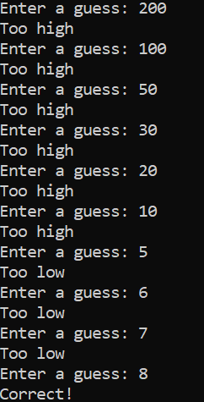

**Deliverables:**

•Your assembly code (.asm) file.

•A screenshot of your code running, proving it works, or showing how far you got.

•The path on the server where it can be found. (run `pwd` to get this)